EX NO: 10
DATE:
ADVENTURE WORKS BI CASE STUDY

AIM: To analyze the Adventure Works dataset using Tableau by creating Bar-in-Bar, Gantt, Step and Jump Line, Funnel, Area Funnel, and Word Cloud charts to compare sales and profit, analyze order quantities, identify trends, and understand business performance across countries, regions, and product sub-categories.
Problem Statement: You are a BI Analyst in Green Eco Corp. The management has asked to analyze their data and create some attractive yet informative visualizations. (Refer the dataset: Adventure Works.csv)

Q1: Create a Bar in Bar chart on Sales and Profit by Country to compare these Measure against one another.
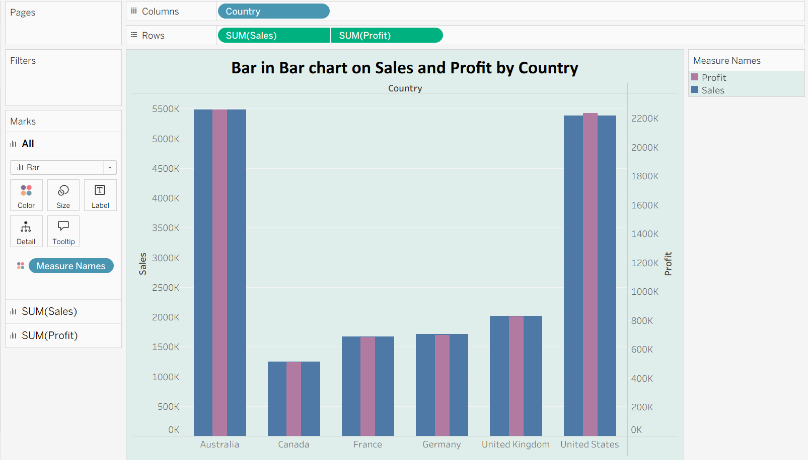
INTERPRETATION: Compares sales and profit across different countries to understand country-wise business performance.

Q2: Create a Gantt chart that displays difference in Order quantity of each Category at Country Level. The duration of the chart should be on Week Continuous level.
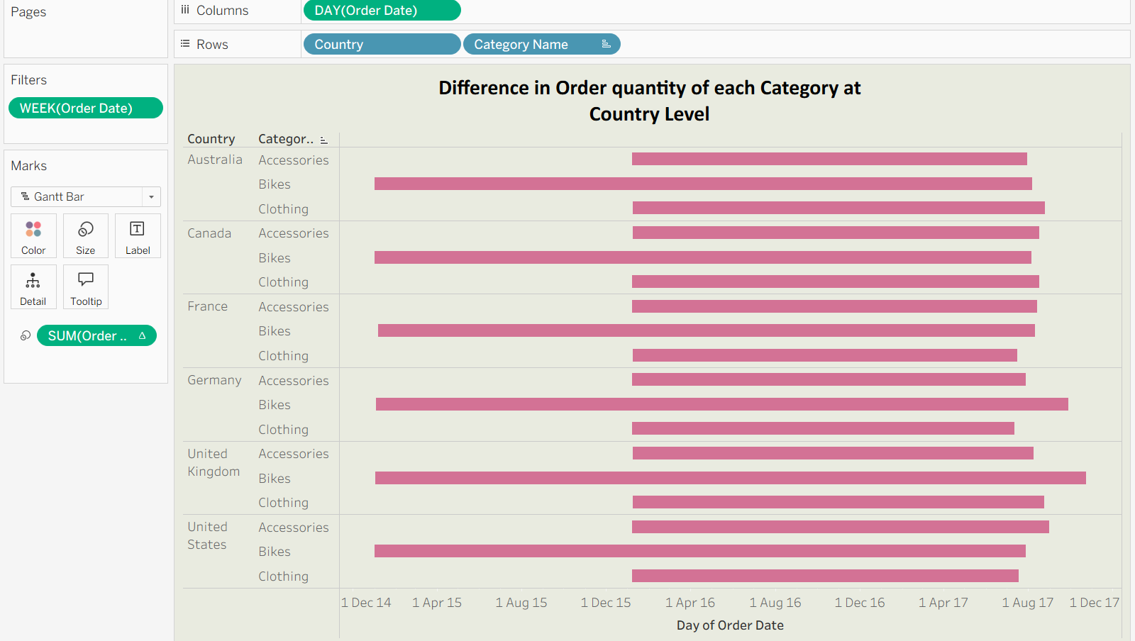
INTERPRETATION: Displays differences in order quantity for each category at the country level using continuous weeks, helping identify changes over time.

Q3: Create a Step and Jump line chart, displaying Cumulative Sum of Sales at Continuous Quarter level.
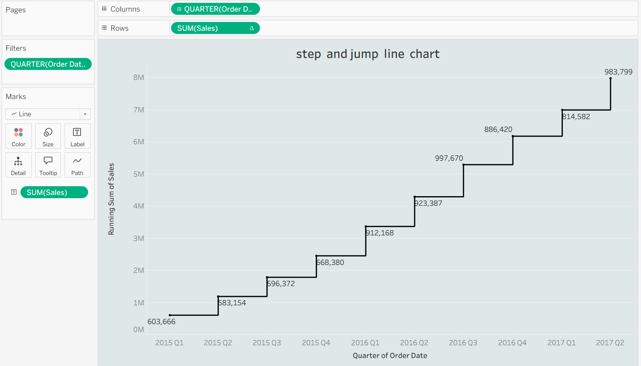
INTERPRETATION: Shows the cumulative sum of sales by continuous quarters and helps track sales growth over time.

Q4: Create a Funnel chart by Profit and Region and find the trend.
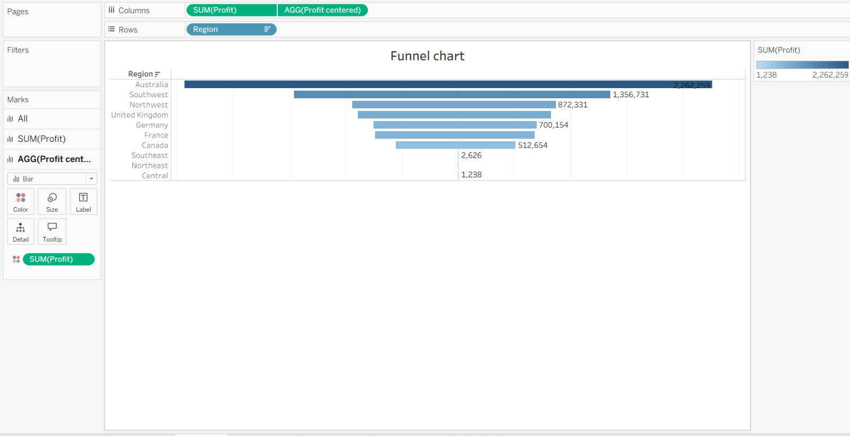
INTERPRETATION: Compares profit across regions and helps identify high- and low-performing regions.

Q5: Create an Area Funnel chart by Order Quantity at Discrete Quarter level also reverse the chart in order to give it a proper funnel shape.
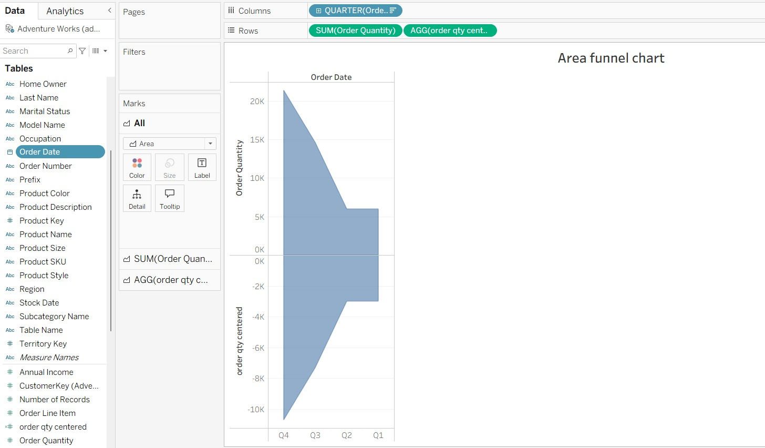
INTERPRETATION: Displays order quantity by discrete quarters in a reversed funnel shape, making it easier to compare order quantities across quarters.

Q6: Create two Word Clouds in two separate sheets. The first chart should be on Sub-category where the Size and Color represent Profit and the second chart should be on Country where Size represents the Sales and Color represents the Country.
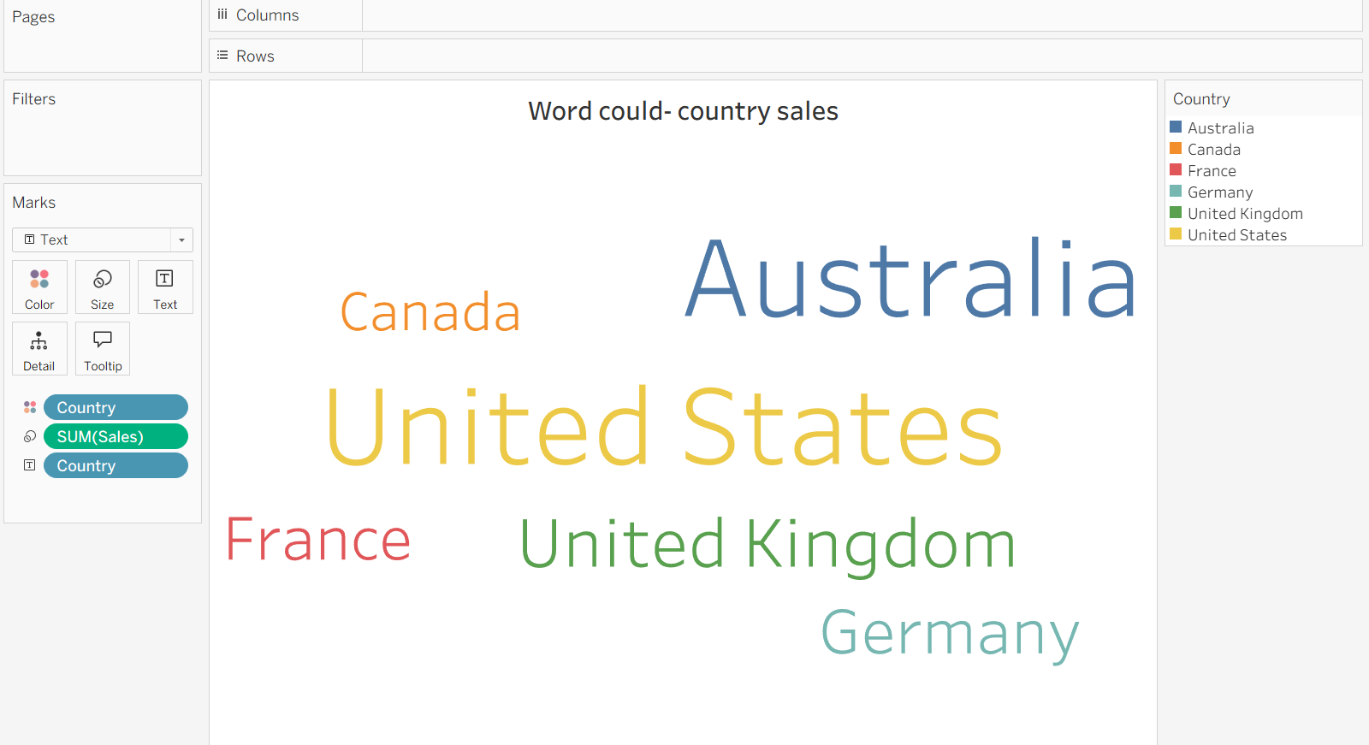
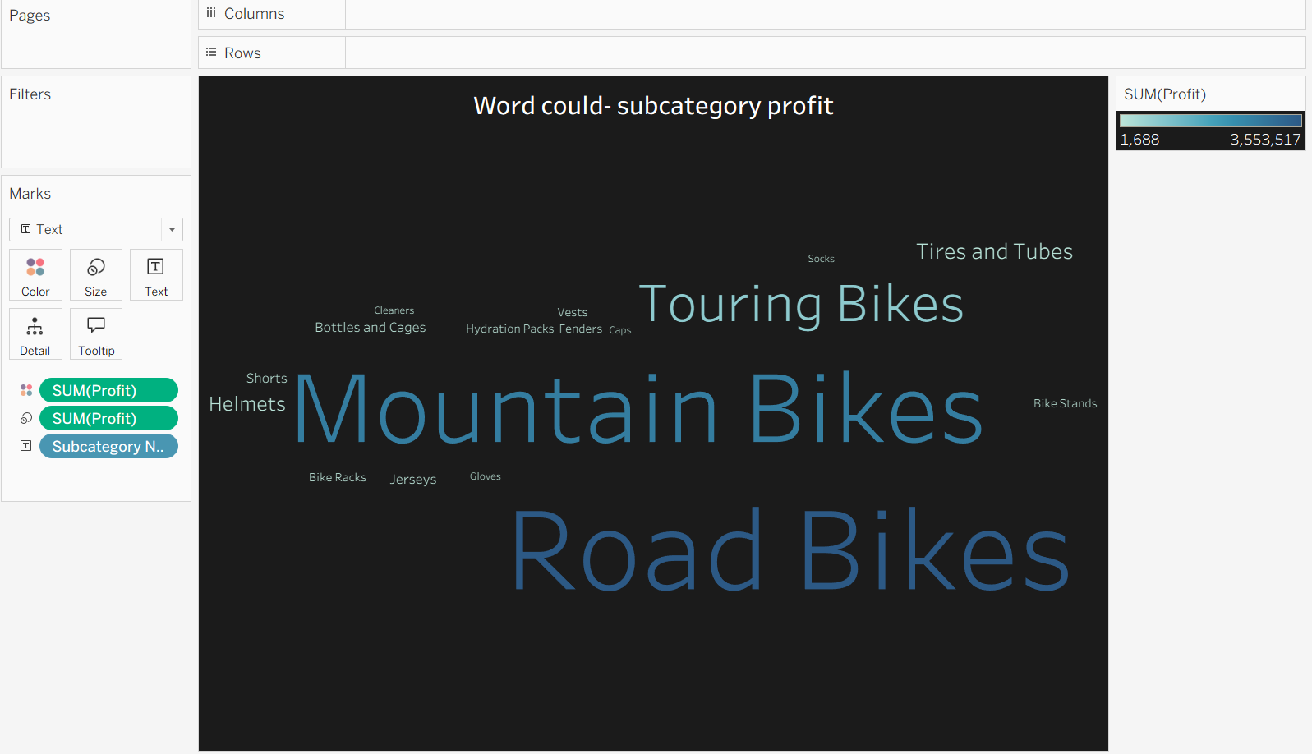
INTERPRETATION: Represents sub-categories using size and color based on profit, helping identify sub-categories with higher or lower profit, Represents countries using sales for word size and country for color, helping visualize sales distribution across countries.

